Finite Element Analysis of Rectangular Slab with Calcpad
Input data  Slab dimensions - $a=6$ m, $b=4$ m  Thickness - $t=0.1$ m  Load - $q=10$ kN/m²  Modulus of elasticity - $E=35000$ MPa  Poisson`s ratio - $ν=0.15$ | 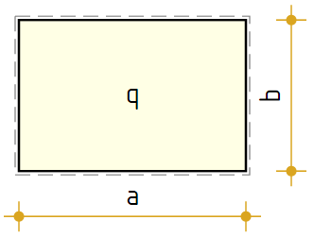
Finite element mesh
We will use rectangular finite element with $n=16$ DOFs
Number of elements along a and b - $n_{a}=6$ , $n_{b}=4$
Total number of elements - $n_{e}=n_{a}·n_{b}=6·4=24$
Total number of joints - $n_{j}=\left(n_{a}+1\right)·\left(n_{b}+1\right)=\left(6+1\right)·\left(4+1\right)=35$
Element dimensions - $a_{1}=\frac{a}{n_{a}}=\frac{6}{6}=1$ , $b_{1}=\frac{b}{n_{b}}=\frac{4}{4}=1$
Supported joints count - $n_{s}=2·\left(n_{a}+n_{b}\right)=2·\left(6+4\right)=20$
Joint coordinates
${\vec{x}}_{j}=\left[0 0 0 0 0 1 1 1 1 1 2 2 2 2 2 3 3 3 3 3 ... 6\right]$ m
${\vec{y}}_{j}=\left[0 1 2 3 4 0 1 2 3 4 0 1 2 3 4 0 1 2 3 4 ... 4\right]$ m
Numbers of elements joints
$$\text{transp}\left(e_{j}\right)=$$
$$\left[\begin{matrix}1 & 2 & 3 & 4 & 6 & 7 & 8 & 9 & 11 & 12 & 13 & 14 & 16 & 17 & 18 & 19 & 21 & 22 & 23 & 24 & ⋯ & 29 \\ 6 & 7 & 8 & 9 & 11 & 12 & 13 & 14 & 16 & 17 & 18 & 19 & 21 & 22 & 23 & 24 & 26 & 27 & 28 & 29 & ⋯ & 34 \\ 7 & 8 & 9 & 10 & 12 & 13 & 14 & 15 & 17 & 18 & 19 & 20 & 22 & 23 & 24 & 25 & 27 & 28 & 29 & 30 & ⋯ & 35 \\ 2 & 3 & 4 & 5 & 7 & 8 & 9 & 10 & 12 & 13 & 14 & 15 & 17 & 18 & 19 & 20 & 22 & 23 & 24 & 25 & ⋯ & 30\end{matrix}\right]$$
Supported joints
$${\vec{s}}_{j}=\left[1 6 11 16 21 26 31 5 10 15 20 25 30 35 2 3 4 32 33 34\right]$$
Coordinates of elements centers
$$j_{e}\left(e\right)=\text{row}\left(e_{j};e\right), x_{c}\left(e\right)=\frac{\text{sum}\left(\text{extract}\left({\vec{x}}_{j};j_{e}\left(e\right)\right)\right)}{4}, y_{c}\left(e\right)=\frac{\text{sum}\left(\text{extract}\left({\vec{y}}_{j};j_{e}\left(e\right)\right)\right)}{4}$$
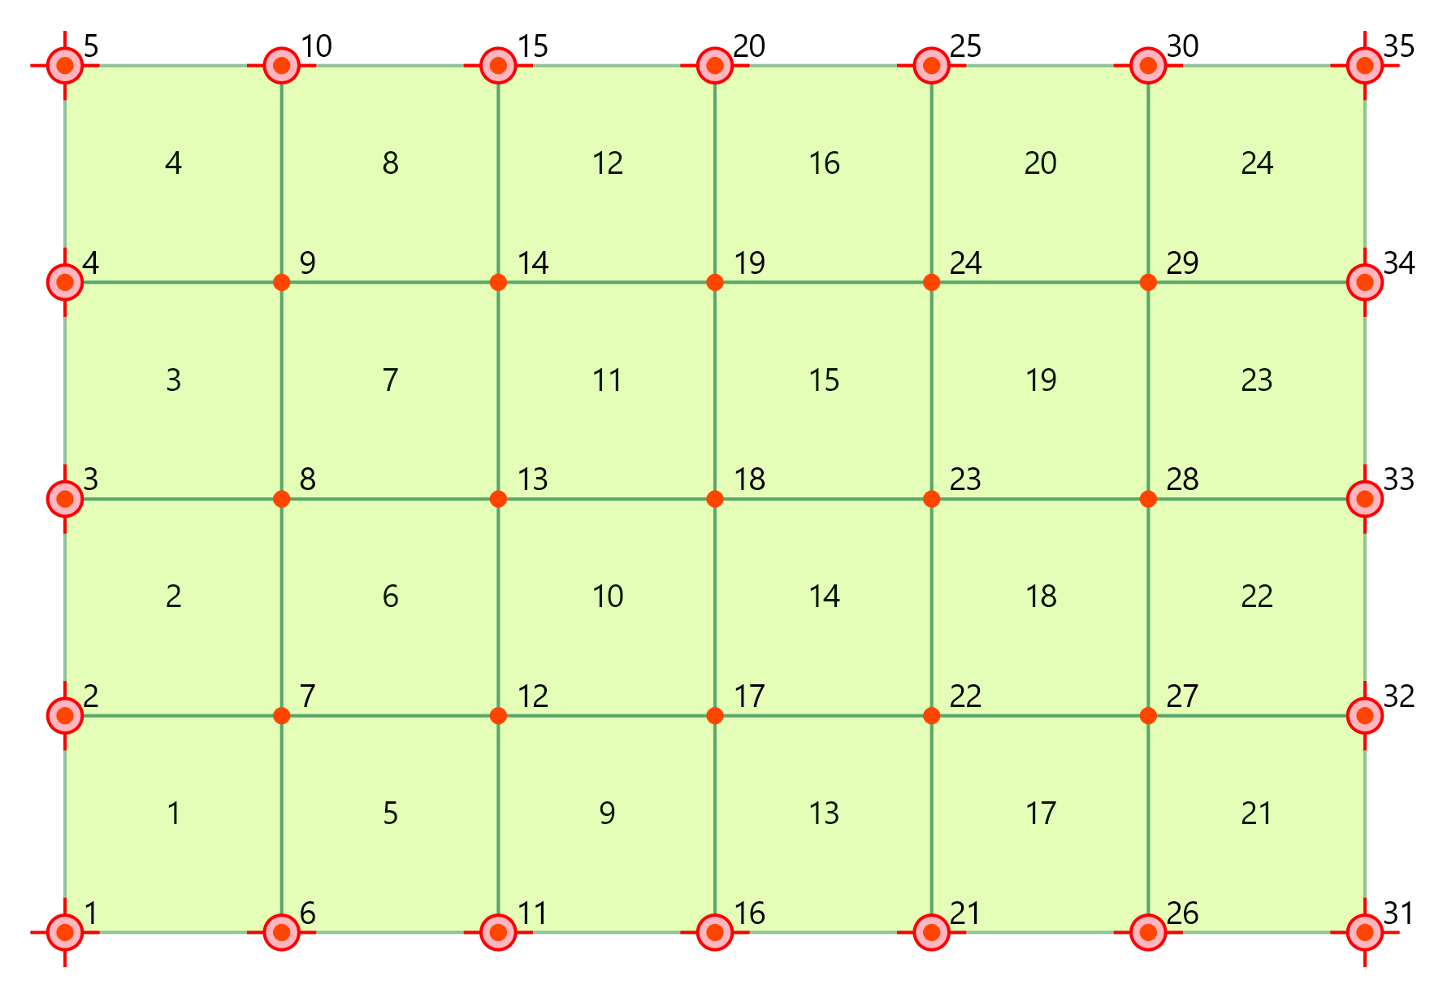
Finite element formulation
Shape functions
Along dimension a
Base functions  $$Φ_{1a}\left(ξ\right)=1-ξ^{2}·\left(3-2·ξ\right)$$  $$Φ_{2a}\left(ξ\right)=ξ·a_{1}·\left(1-ξ·\left(2-ξ\right)\right)$$  $$Φ_{3a}\left(ξ\right)=ξ^{2}·\left(3-2·ξ\right)$$  $$Φ_{4a}\left(ξ\right)=ξ^{2}·a_{1}·\left(\text{-}1+ξ\right)$$ | First derivatives  $${Φ'}_{1a}\left(ξ\right)=\text{-}6·\frac{ξ}{a_{1}}·\left(1-ξ\right)$$  $${Φ'}_{2a}\left(ξ\right)=1-ξ·\left(4-3·ξ\right)$$  $${Φ'}_{3a}\left(ξ\right)=6·\frac{ξ}{a_{1}}·\left(1-ξ\right)$$  $${Φ'}_{4a}\left(ξ\right)=\text{-}ξ·\left(2-3·ξ\right)$$ | Second derivatives  $${Φ″}_{1a}\left(ξ\right)=\text{-}\frac{6}{{a_{1}}^{2}}·\left(1-2·ξ\right)$$  $${Φ″}_{2a}\left(ξ\right)=\text{-}\frac{2}{a_{1}}·\left(2-3·ξ\right)$$  $${Φ″}_{3a}\left(ξ\right)=\frac{6}{{a_{1}}^{2}}·\left(1-2·ξ\right)$$  $${Φ″}_{4a}\left(ξ\right)=\text{-}\frac{2}{a_{1}}·\left(1-3·ξ\right)$$
Along dimension b
Base functions  $$Φ_{1b}\left(η\right)=1-η^{2}·\left(3-2·η\right)$$  $$Φ_{2b}\left(η\right)=η·b_{1}·\left(1-η·\left(2-η\right)\right)$$  $$Φ_{3b}\left(η\right)=η^{2}·\left(3-2·η\right)$$  $$Φ_{4b}\left(η\right)=η^{2}·b_{1}·\left(\text{-}1+η\right)$$ | First derivatives  $${Φ'}_{1b}\left(η\right)=\text{-}6·\frac{η}{b_{1}}·\left(1-η\right)$$  $${Φ'}_{2b}\left(η\right)=1-η·\left(4-3·η\right)$$  $${Φ'}_{3b}\left(η\right)=6·\frac{η}{b_{1}}·\left(1-η\right)$$  $${Φ'}_{4b}\left(η\right)=\text{-}η·\left(2-3·η\right)$$ | Second derivatives  $${Φ″}_{1b}\left(η\right)=\text{-}\frac{6}{{b_{1}}^{2}}·\left(1-2·η\right)$$  $${Φ″}_{2b}\left(η\right)=\text{-}\frac{2}{b_{1}}·\left(2-3·η\right)$$  $${Φ″}_{3b}\left(η\right)=\frac{6}{{b_{1}}^{2}}·\left(1-2·η\right)$$  $${Φ″}_{4b}\left(η\right)=\text{-}\frac{2}{b_{1}}·\left(1-3·η\right)$$
For vertical displacements  w$N_{1,w}\left(ξ;η\right)=Φ_{1a}\left(ξ\right)·Φ_{1b}\left(η\right)$  $$N_{2,w}\left(ξ;η\right)=Φ_{3a}\left(ξ\right)·Φ_{1b}\left(η\right)$$  $$N_{3,w}\left(ξ;η\right)=Φ_{3a}\left(ξ\right)·Φ_{3b}\left(η\right)$$  $$N_{4,w}\left(ξ;η\right)=Φ_{1a}\left(ξ\right)·Φ_{3b}\left(η\right)$$ | For rotations θₓ  $$N_{1,θₓ}\left(ξ;η\right)=Φ_{2a}\left(ξ\right)·Φ_{1b}\left(η\right)$$  $$N_{2,θₓ}\left(ξ;η\right)=Φ_{4a}\left(ξ\right)·Φ_{1b}\left(η\right)$$  $$N_{3,θₓ}\left(ξ;η\right)=Φ_{4a}\left(ξ\right)·Φ_{3b}\left(η\right)$$  $$N_{4,θₓ}\left(ξ;η\right)=Φ_{2a}\left(ξ\right)·Φ_{3b}\left(η\right)$$ | For rotations θᵧ  $$N_{1,θᵧ}\left(ξ;η\right)=Φ_{1a}\left(ξ\right)·Φ_{2b}\left(η\right)$$  $$N_{2,θᵧ}\left(ξ;η\right)=Φ_{3a}\left(ξ\right)·Φ_{2b}\left(η\right)$$  $$N_{3,θᵧ}\left(ξ;η\right)=Φ_{3a}\left(ξ\right)·Φ_{4b}\left(η\right)$$  $$N_{4,θᵧ}\left(ξ;η\right)=Φ_{1a}\left(ξ\right)·Φ_{4b}\left(η\right)$$
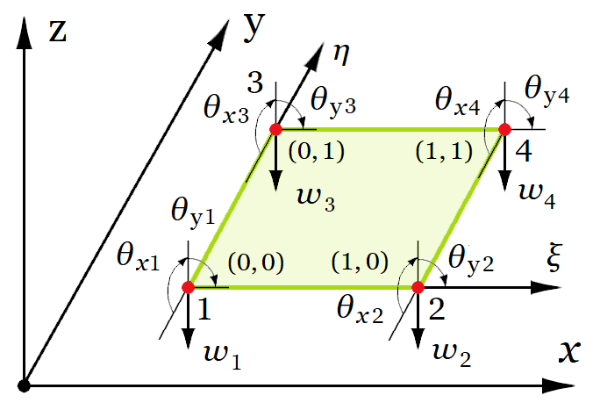
For twist ψ
$$N_{1,ψ}\left(ξ;η\right)=Φ_{2a}\left(ξ\right)·Φ_{2b}\left(η\right)$$
$$N_{2,ψ}\left(ξ;η\right)=Φ_{4a}\left(ξ\right)·Φ_{2b}\left(η\right)$$
$$N_{3,ψ}\left(ξ;η\right)=Φ_{4a}\left(ξ\right)·Φ_{4b}\left(η\right)$$
$$N_{4,ψ}\left(ξ;η\right)=Φ_{2a}\left(ξ\right)·Φ_{4b}\left(η\right)$$
Shape functions vector
$$N\left(i;ξ;η\right) = take \text{(}i;N_{1,w}\left(ξ;η\right);N_{1,θₓ}\left(ξ;η\right);N_{1,θᵧ}\left(ξ;η\right);N_{1,ψ}\left(ξ;η\right);$$
$$N_{2,w}\left(ξ;η\right);N_{2,θₓ}\left(ξ;η\right);N_{2,θᵧ}\left(ξ;η\right);N_{2,ψ}\left(ξ;η\right);$$
$$N_{3,w}\left(ξ;η\right);N_{3,θₓ}\left(ξ;η\right);N_{3,θᵧ}\left(ξ;η\right);N_{3,ψ}\left(ξ;η\right);$$
$$N_{4,w}\left(ξ;η\right);N_{4,θₓ}\left(ξ;η\right);N_{4,θᵧ}\left(ξ;η\right);N_{4,ψ}\left(ξ;η\right)\text{)}$$
Constitutive matrix (stress - strain relationship)
$$D=\frac{E·t^{3}}{12·\left(1-ν^{2}\right)}·\left[1;ν;0 | ν;1;0 | 0;0;\frac{1-ν}{2}\right]=$$
$$\frac{35000·{0.1}^{3}}{12·\left(1-{0.15}^{2}\right)}·\left[1;0.15;0 | 0.15;1;0 | 0;0;\frac{1-0.15}{2}\right]=\left[\begin{matrix}2.98 & 0.448 & 0 \\ 0.448 & 2.98 & 0 \\ 0 & 0 & 1.27\end{matrix}\right]$$
Strain-displacement matrix
$$B_{1}\left(j;ξ;η\right)=\text{take}\left(j;{Φ″}_{1a}\left(ξ\right)·Φ_{1b}\left(η\right);{Φ″}_{2a}\left(ξ\right)·Φ_{1b}\left(η\right);{Φ″}_{1a}\left(ξ\right)·Φ_{2b}\left(η\right);{Φ″}_{2a}\left(ξ\right)·Φ_{2b}\left(η\right);{Φ″}_{3a}\left(ξ\right)·Φ_{1b}\left(η\right);{Φ″}_{4a}\left(ξ\right)·Φ_{1b}\left(η\right);{Φ″}_{3a}\left(ξ\right)·Φ_{2b}\left(η\right);{Φ″}_{4a}\left(ξ\right)·Φ_{2b}\left(η\right);{Φ″}_{3a}\left(ξ\right)·Φ_{3b}\left(η\right);{Φ″}_{4a}\left(ξ\right)·Φ_{3b}\left(η\right);{Φ″}_{3a}\left(ξ\right)·Φ_{4b}\left(η\right);{Φ″}_{4a}\left(ξ\right)·Φ_{4b}\left(η\right);{Φ″}_{1a}\left(ξ\right)·Φ_{3b}\left(η\right);{Φ″}_{2a}\left(ξ\right)·Φ_{3b}\left(η\right);{Φ″}_{1a}\left(ξ\right)·Φ_{4b}\left(η\right);{Φ″}_{2a}\left(ξ\right)·Φ_{4b}\left(η\right)\right)$$
$$B_{2}\left(j;ξ;η\right)=\text{take}\left(j;Φ_{1a}\left(ξ\right)·{Φ″}_{1b}\left(η\right);Φ_{2a}\left(ξ\right)·{Φ″}_{1b}\left(η\right);Φ_{1a}\left(ξ\right)·{Φ″}_{2b}\left(η\right);Φ_{2a}\left(ξ\right)·{Φ″}_{2b}\left(η\right);Φ_{3a}\left(ξ\right)·{Φ″}_{1b}\left(η\right);Φ_{4a}\left(ξ\right)·{Φ″}_{1b}\left(η\right);Φ_{3a}\left(ξ\right)·{Φ″}_{2b}\left(η\right);Φ_{4a}\left(ξ\right)·{Φ″}_{2b}\left(η\right);Φ_{3a}\left(ξ\right)·{Φ″}_{3b}\left(η\right);Φ_{4a}\left(ξ\right)·{Φ″}_{3b}\left(η\right);Φ_{3a}\left(ξ\right)·{Φ″}_{4b}\left(η\right);Φ_{4a}\left(ξ\right)·{Φ″}_{4b}\left(η\right);Φ_{1a}\left(ξ\right)·{Φ″}_{3b}\left(η\right);Φ_{2a}\left(ξ\right)·{Φ″}_{3b}\left(η\right);Φ_{1a}\left(ξ\right)·{Φ″}_{4b}\left(η\right);Φ_{2a}\left(ξ\right)·{Φ″}_{4b}\left(η\right)\right)$$
$$B_{3}\left(j;ξ;η\right)=2 \text{take}\left(j;{Φ'}_{1a}\left(ξ\right)·{Φ'}_{1b}\left(η\right);{Φ'}_{2a}\left(ξ\right)·{Φ'}_{1b}\left(η\right);{Φ'}_{1a}\left(ξ\right)·{Φ'}_{2b}\left(η\right);{Φ'}_{2a}\left(ξ\right)·{Φ'}_{2b}\left(η\right);{Φ'}_{3a}\left(ξ\right)·{Φ'}_{1b}\left(η\right);{Φ'}_{4a}\left(ξ\right)·{Φ'}_{1b}\left(η\right);{Φ'}_{3a}\left(ξ\right)·{Φ'}_{2b}\left(η\right);{Φ'}_{4a}\left(ξ\right)·{Φ'}_{2b}\left(η\right);{Φ'}_{3a}\left(ξ\right)·{Φ'}_{3b}\left(η\right);{Φ'}_{4a}\left(ξ\right)·{Φ'}_{3b}\left(η\right);{Φ'}_{3a}\left(ξ\right)·{Φ'}_{4b}\left(η\right);{Φ'}_{4a}\left(ξ\right)·{Φ'}_{4b}\left(η\right);{Φ'}_{1a}\left(ξ\right)·{Φ'}_{3b}\left(η\right);{Φ'}_{2a}\left(ξ\right)·{Φ'}_{3b}\left(η\right);{Φ'}_{1a}\left(ξ\right)·{Φ'}_{4b}\left(η\right);{Φ'}_{2a}\left(ξ\right)·{Φ'}_{4b}\left(η\right)\right)$$
$$B\left(j;ξ;η\right)=\left[B_{1}\left(j;ξ;η\right);B_{2}\left(j;ξ;η\right);B_{3}\left(j;ξ;η\right)\right]$$
$x_{1}\left(e\right)={{\vec{x}}_{j}}_{.{e_{j}}_{.e,1}}$ , $y_{1}\left(e\right)={{\vec{y}}_{j}}_{.{e_{j}}_{.e,1}}$
The elements of the stiffness matrix will be calculated by using the equation
$$K_{e,ij}=a_{1}·b_{1}·\int_{0}^{1}{\int_{0}^{1}{{B_{i}\left(ξ;η\right)}^{T}·D·B_{j}\left(ξ;η\right) dξ} dη}$$
Element stiffness matrix
(above the main diagonal only)
$${BTDB}_{e}\left(i;j;ξ;η\right)=\text{transp}\left(B\left(i;ξ;η\right)\right)·D·B\left(j;ξ;η\right)$$
$$K_{e}\left(i;j\right)=a_{1}·b_{1}·\int_{0}^{1}{\int_{0}^{1}{{BTDB}_{e}\left(i;j;ξ;η\right) dη} dξ}$$
$$\$Repeat\left\{\$Repeat\left\{{K_{e}}_{.i,j}=K_{e}\left(i;j\right);j=i...n\right\};i=1...n\right\}=0.333$$
$$K_{e}=$$
$$\left[\begin{matrix}\text{35.19} & \text{9.78} & \text{9.78} & \text{2.02} & \text{-}\text{17.29} & \text{6.26} & \text{-}\text{0.827} & \text{0.488} & \text{-}\text{0.614} & \text{2.69} & \text{2.69} & \text{-}\text{1.05} & \text{-}\text{17.29} & \text{-}\text{0.827} & \text{6.26} & \text{0.488} \\ \text{0} & \text{5.73} & \text{2.47} & \text{0.935} & \text{-}\text{6.26} & \text{1.72} & \text{-}\text{0.488} & \text{0.15} & \text{-}\text{2.69} & \text{1.26} & \text{1.05} & \text{-}\text{0.332} & \text{-}\text{0.827} & \text{0.239} & \text{0.488} & \text{-}\text{0.119} \\ \text{0} & \text{0} & \text{5.73} & \text{0.935} & \text{-}\text{0.827} & \text{0.488} & \text{0.239} & \text{-}\text{0.119} & \text{-}\text{2.69} & \text{1.05} & \text{1.26} & \text{-}\text{0.332} & \text{-}\text{6.26} & \text{-}\text{0.488} & \text{1.72} & \text{0.15} \\ \text{0} & \text{0} & \text{0} & \text{0.333} & \text{-}\text{0.488} & \text{0.15} & \text{0.119} & \text{-}\text{0.0549} & \text{-}\text{1.05} & \text{0.332} & \text{0.332} & \text{-}\text{0.0786} & \text{-}\text{0.488} & \text{0.119} & \text{0.15} & \text{-}\text{0.0549} \\ \text{0} & \text{0} & \text{0} & \text{0} & \text{35.19} & \text{-}\text{9.78} & \text{9.78} & \text{-}\text{2.02} & \text{-}\text{17.29} & \text{0.827} & \text{6.26} & \text{-}\text{0.488} & \text{-}\text{0.614} & \text{-}\text{2.69} & \text{2.69} & \text{1.05} \\ \text{0} & \text{0} & \text{0} & \text{0} & \text{0} & \text{5.73} & \text{-}\text{2.47} & \text{0.935} & \text{0.827} & \text{0.239} & \text{-}\text{0.488} & \text{-}\text{0.119} & \text{2.69} & \text{1.26} & \text{-}\text{1.05} & \text{-}\text{0.332} \\ \text{0} & \text{0} & \text{0} & \text{0} & \text{0} & \text{0} & \text{5.73} & \text{-}\text{0.935} & \text{-}\text{6.26} & \text{0.488} & \text{1.72} & \text{-}\text{0.15} & \text{-}\text{2.69} & \text{-}\text{1.05} & \text{1.26} & \text{0.332} \\ \text{0} & \text{0} & \text{0} & \text{0} & \text{0} & \text{0} & \text{0} & \text{0.333} & \text{0.488} & \text{0.119} & \text{-}\text{0.15} & \text{-}\text{0.0549} & \text{1.05} & \text{0.332} & \text{-}\text{0.332} & \text{-}\text{0.0786} \\ \text{0} & \text{0} & \text{0} & \text{0} & \text{0} & \text{0} & \text{0} & \text{0} & \text{35.19} & \text{-}\text{9.78} & \text{-}\text{9.78} & \text{2.02} & \text{-}\text{17.29} & \text{-}\text{6.26} & \text{0.827} & \text{0.488} \\ \text{0} & \text{0} & \text{0} & \text{0} & \text{0} & \text{0} & \text{0} & \text{0} & \text{0} & \text{5.73} & \text{2.47} & \text{-}\text{0.935} & \text{6.26} & \text{1.72} & \text{-}\text{0.488} & \text{-}\text{0.15} \\ \text{0} & \text{0} & \text{0} & \text{0} & \text{0} & \text{0} & \text{0} & \text{0} & \text{0} & \text{0} & \text{5.73} & \text{-}\text{0.935} & \text{0.827} & \text{0.488} & \text{0.239} & \text{0.119} \\ \text{0} & \text{0} & \text{0} & \text{0} & \text{0} & \text{0} & \text{0} & \text{0} & \text{0} & \text{0} & \text{0} & \text{0.333} & \text{-}\text{0.488} & \text{-}\text{0.15} & \text{-}\text{0.119} & \text{-}\text{0.0549} \\ \text{0} & \text{0} & \text{0} & \text{0} & \text{0} & \text{0} & \text{0} & \text{0} & \text{0} & \text{0} & \text{0} & \text{0} & \text{35.19} & \text{9.78} & \text{-}\text{9.78} & \text{-}\text{2.02} \\ \text{0} & \text{0} & \text{0} & \text{0} & \text{0} & \text{0} & \text{0} & \text{0} & \text{0} & \text{0} & \text{0} & \text{0} & \text{0} & \text{5.73} & \text{-}\text{2.47} & \text{-}\text{0.935} \\ \text{0} & \text{0} & \text{0} & \text{0} & \text{0} & \text{0} & \text{0} & \text{0} & \text{0} & \text{0} & \text{0} & \text{0} & \text{0} & \text{0} & \text{5.73} & \text{0.935} \\ \text{0} & \text{0} & \text{0} & \text{0} & \text{0} & \text{0} & \text{0} & \text{0} & \text{0} & \text{0} & \text{0} & \text{0} & \text{0} & \text{0} & \text{0} & \text{0.333}\end{matrix}\right]$$
Element load vector
$$F_{e,i}=a_{1}·b_{1}·\int_{0}^{1}{\int_{0}^{1}{{N_{i}\left(ξ;η\right)}^{T}·q dξ} dη}$$
$${\vec{F}}_{e}=\left[\text{2.5} \text{0.417} \text{0.417} \text{0.0}\text{7} \text{2.5} \text{-}\text{0.417} \text{0.417} \text{-}\text{0.0}\text{7} \text{2.5} \text{-}\text{0.417} \text{-}\text{0.417} \text{0.0}\text{7} \text{2.5} \text{0.417} \text{-}\text{0.417} \text{-}\text{0.0}\text{7}\right] kN$$
Solution
Global stiffness matrix $K=$
$$\left[\begin{matrix}\text{1}\text{×}{\text{10}}^{\text{20}} & \text{9.78} & \text{9.78} & \text{2.02} & \text{-}\text{17.29} & \text{-}\text{0.827} & \text{6.26} & \text{0.488} & \text{0} & \text{0} & \text{0} & \text{0} & \text{0} & \text{0} & \text{0} & \text{0} & \text{0} & \text{0} & \text{0} & \text{0} & \text{⋯} & \text{0} \\ \text{9.78} & \text{1}\text{×}{\text{10}}^{\text{20}} & \text{2.47} & \text{0.935} & \text{-}\text{0.827} & \text{0.239} & \text{0.488} & \text{-}\text{0.119} & \text{0} & \text{0} & \text{0} & \text{0} & \text{0} & \text{0} & \text{0} & \text{0} & \text{0} & \text{0} & \text{0} & \text{0} & \text{⋯} & \text{0} \\ \text{9.78} & \text{2.47} & \text{1}\text{×}{\text{10}}^{\text{20}} & \text{0.935} & \text{-}\text{6.26} & \text{-}\text{0.488} & \text{1.72} & \text{0.15} & \text{0} & \text{0} & \text{0} & \text{0} & \text{0} & \text{0} & \text{0} & \text{0} & \text{0} & \text{0} & \text{0} & \text{0} & \text{⋯} & \text{0} \\ \text{2.02} & \text{0.935} & \text{0.935} & \text{0.333} & \text{-}\text{0.488} & \text{0.119} & \text{0.15} & \text{-}\text{0.0549} & \text{0} & \text{0} & \text{0} & \text{0} & \text{0} & \text{0} & \text{0} & \text{0} & \text{0} & \text{0} & \text{0} & \text{0} & \text{⋯} & \text{0} \\ \text{-}\text{17.29} & \text{-}\text{0.827} & \text{-}\text{6.26} & \text{-}\text{0.488} & \text{1}\text{×}{\text{10}}^{\text{20}} & \text{19.56} & \text{0} & \text{0} & \text{-}\text{17.29} & \text{-}\text{0.827} & \text{6.26} & \text{0.488} & \text{0} & \text{0} & \text{0} & \text{0} & \text{0} & \text{0} & \text{0} & \text{0} & \text{⋯} & \text{0} \\ \text{-}\text{0.827} & \text{0.239} & \text{-}\text{0.488} & \text{0.119} & \text{19.56} & \text{11.46} & \text{0} & \text{0} & \text{-}\text{0.827} & \text{0.239} & \text{0.488} & \text{-}\text{0.119} & \text{0} & \text{0} & \text{0} & \text{0} & \text{0} & \text{0} & \text{0} & \text{0} & \text{⋯} & \text{0} \\ \text{6.26} & \text{0.488} & \text{1.72} & \text{0.15} & \text{0} & \text{0} & \text{1}\text{×}{\text{10}}^{\text{20}} & \text{1.87} & \text{-}\text{6.26} & \text{-}\text{0.488} & \text{1.72} & \text{0.15} & \text{0} & \text{0} & \text{0} & \text{0} & \text{0} & \text{0} & \text{0} & \text{0} & \text{⋯} & \text{0} \\ \text{0.488} & \text{-}\text{0.119} & \text{0.15} & \text{-}\text{0.0549} & \text{0} & \text{0} & \text{1.87} & \text{0.667} & \text{-}\text{0.488} & \text{0.119} & \text{0.15} & \text{-}\text{0.0549} & \text{0} & \text{0} & \text{0} & \text{0} & \text{0} & \text{0} & \text{0} & \text{0} & \text{⋯} & \text{0} \\ \text{0} & \text{0} & \text{0} & \text{0} & \text{-}\text{17.29} & \text{-}\text{0.827} & \text{-}\text{6.26} & \text{-}\text{0.488} & \text{1}\text{×}{\text{10}}^{\text{20}} & \text{19.56} & \text{0} & \text{0} & \text{-}\text{17.29} & \text{-}\text{0.827} & \text{6.26} & \text{0.488} & \text{0} & \text{0} & \text{0} & \text{0} & \text{⋯} & \text{0} \\ \text{0} & \text{0} & \text{0} & \text{0} & \text{-}\text{0.827} & \text{0.239} & \text{-}\text{0.488} & \text{0.119} & \text{19.56} & \text{11.46} & \text{0} & \text{0} & \text{-}\text{0.827} & \text{0.239} & \text{0.488} & \text{-}\text{0.119} & \text{0} & \text{0} & \text{0} & \text{0} & \text{⋯} & \text{0} \\ \text{0} & \text{0} & \text{0} & \text{0} & \text{6.26} & \text{0.488} & \text{1.72} & \text{0.15} & \text{0} & \text{0} & \text{1}\text{×}{\text{10}}^{\text{20}} & \text{1.87} & \text{-}\text{6.26} & \text{-}\text{0.488} & \text{1.72} & \text{0.15} & \text{0} & \text{0} & \text{0} & \text{0} & \text{⋯} & \text{0} \\ \text{0} & \text{0} & \text{0} & \text{0} & \text{0.488} & \text{-}\text{0.119} & \text{0.15} & \text{-}\text{0.0549} & \text{0} & \text{0} & \text{1.87} & \text{0.667} & \text{-}\text{0.488} & \text{0.119} & \text{0.15} & \text{-}\text{0.0549} & \text{0} & \text{0} & \text{0} & \text{0} & \text{⋯} & \text{0} \\ \text{0} & \text{0} & \text{0} & \text{0} & \text{0} & \text{0} & \text{0} & \text{0} & \text{-}\text{17.29} & \text{-}\text{0.827} & \text{-}\text{6.26} & \text{-}\text{0.488} & \text{1}\text{×}{\text{10}}^{\text{20}} & \text{19.56} & \text{0} & \text{0} & \text{-}\text{17.29} & \text{-}\text{0.827} & \text{6.26} & \text{0.488} & \text{⋯} & \text{0} \\ \text{0} & \text{0} & \text{0} & \text{0} & \text{0} & \text{0} & \text{0} & \text{0} & \text{-}\text{0.827} & \text{0.239} & \text{-}\text{0.488} & \text{0.119} & \text{19.56} & \text{11.46} & \text{0} & \text{0} & \text{-}\text{0.827} & \text{0.239} & \text{0.488} & \text{-}\text{0.119} & \text{⋯} & \text{0} \\ \text{0} & \text{0} & \text{0} & \text{0} & \text{0} & \text{0} & \text{0} & \text{0} & \text{6.26} & \text{0.488} & \text{1.72} & \text{0.15} & \text{0} & \text{0} & \text{1}\text{×}{\text{10}}^{\text{20}} & \text{1.87} & \text{-}\text{6.26} & \text{-}\text{0.488} & \text{1.72} & \text{0.15} & \text{⋯} & \text{0} \\ \text{0} & \text{0} & \text{0} & \text{0} & \text{0} & \text{0} & \text{0} & \text{0} & \text{0.488} & \text{-}\text{0.119} & \text{0.15} & \text{-}\text{0.0549} & \text{0} & \text{0} & \text{1.87} & \text{0.667} & \text{-}\text{0.488} & \text{0.119} & \text{0.15} & \text{-}\text{0.0549} & \text{⋯} & \text{0} \\ \text{0} & \text{0} & \text{0} & \text{0} & \text{0} & \text{0} & \text{0} & \text{0} & \text{0} & \text{0} & \text{0} & \text{0} & \text{-}\text{17.29} & \text{-}\text{0.827} & \text{-}\text{6.26} & \text{-}\text{0.488} & \text{1}\text{×}{\text{10}}^{\text{20}} & \text{9.78} & \text{-}\text{9.78} & \text{-}\text{2.02} & \text{⋯} & \text{0} \\ \text{0} & \text{0} & \text{0} & \text{0} & \text{0} & \text{0} & \text{0} & \text{0} & \text{0} & \text{0} & \text{0} & \text{0} & \text{-}\text{0.827} & \text{0.239} & \text{-}\text{0.488} & \text{0.119} & \text{9.78} & \text{1}\text{×}{\text{10}}^{\text{20}} & \text{-}\text{2.47} & \text{-}\text{0.935} & \text{⋯} & \text{0} \\ \text{0} & \text{0} & \text{0} & \text{0} & \text{0} & \text{0} & \text{0} & \text{0} & \text{0} & \text{0} & \text{0} & \text{0} & \text{6.26} & \text{0.488} & \text{1.72} & \text{0.15} & \text{-}\text{9.78} & \text{-}\text{2.47} & \text{1}\text{×}{\text{10}}^{\text{20}} & \text{0.935} & \text{⋯} & \text{0} \\ \text{0} & \text{0} & \text{0} & \text{0} & \text{0} & \text{0} & \text{0} & \text{0} & \text{0} & \text{0} & \text{0} & \text{0} & \text{0.488} & \text{-}\text{0.119} & \text{0.15} & \text{-}\text{0.0549} & \text{-}\text{2.02} & \text{-}\text{0.935} & \text{0.935} & \text{0.333} & \text{⋯} & \text{0} \\ \text{⋮} & \text{⋮} & \text{⋮} & \text{⋮} & \text{⋮} & \text{⋮} & \text{⋮} & \text{⋮} & \text{⋮} & \text{⋮} & \text{⋮} & \text{⋮} & \text{⋮} & \text{⋮} & \text{⋮} & \text{⋮} & \text{⋮} & \text{⋮} & \text{⋮} & \text{⋮} & \text{⋱} & \text{⋮} \\ \text{0} & \text{0} & \text{0} & \text{0} & \text{0} & \text{0} & \text{0} & \text{0} & \text{0} & \text{0} & \text{0} & \text{0} & \text{0} & \text{0} & \text{0} & \text{0} & \text{0} & \text{0} & \text{0} & \text{0} & \text{⋯} & \text{0.333}\end{matrix}\right]$$
Global load vector
$$\vec{F}\text{=}\left[\text{2.5} \text{0.417} \text{0.417} \text{0.0694} \text{5} \text{0.833} \text{0} \text{0} \text{5} \text{0.833} \text{0} \text{0} \text{5} \text{0.833} \text{0} \text{0} \text{2.5} \text{0.417} \text{-}\text{0.417} \text{-}\text{0.0694} \text{...} \text{0.0694}\right] kN$$
Solution of the system of equations
$$\vec{Z}=\text{clsolve}\left(K;\vec{F}\right)=\left[\text{0} \text{0} \text{0} \text{3.3} \text{0} \text{2.84} \text{0} \text{2.09} \text{0} \text{3.91} \text{0} \text{0} \text{0} \text{2.84} \text{0} \text{-}\text{2.09} \text{0} \text{0} \text{0} \text{-}\text{3.3} \text{...} \text{3.3}\right] mm$$
Results
Joint displacements
$\text{transp}\left(W_{z}\right)=\left[\begin{matrix}0 & 0 & 0 & 0 & 0 & 0 & 0 \\ 0 & 2.58 & 4.21 & 4.75 & 4.21 & 2.58 & 0 \\ 0 & 3.59 & 5.87 & 6.63 & 5.87 & 3.59 & 0 \\ 0 & 2.58 & 4.21 & 4.75 & 4.21 & 2.58 & 0 \\ 0 & 0 & 0 & 0 & 0 & 0 & 0\end{matrix}\right]$ mm
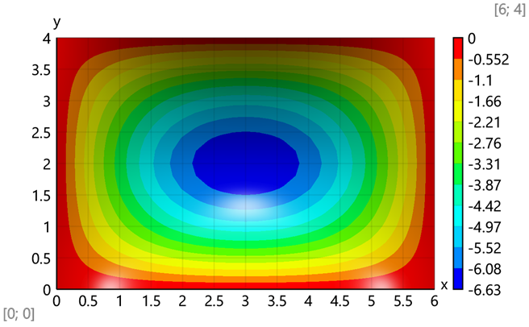
$$\text{Maximal value -} w\left(\frac{a}{2};\frac{b}{2}\right)=w\left(\frac{6}{2};\frac{4}{2}\right)=6.63 mm$$
Bending moments
$$Z_{j}\left(j\right)=\text{slice}\left(\vec{Z};k_{1}·\left(j-1\right)+1;k_{1}·j\right)$$
$$Z_{e}\left(e\right)=\left[Z_{j}\left({e_{j}}_{.e,1}\right);Z_{j}\left({e_{j}}_{.e,2}\right);Z_{j}\left({e_{j}}_{.e,3}\right);Z_{j}\left({e_{j}}_{.e,4}\right)\right]$$
Results for element 15 and joint 18:
$${\vec{Z}}_{e}=Z_{e}\left(e\right)=Z_{e}\left(15\right)=\left[6.63 0 0 0 5.87 \text{-}1.52 0 0 4.21 \text{-}1.08 \text{-}3.2 0.84 4.75 0 \text{-}3.62 0\right] mm$$
$$M_{e}\left(x;y\right)=\text{-}D·B\left(\frac{x}{a_{1}};\frac{y}{b_{1}}\right)·Z_{e}\left(e\right)$$
$${\vec{M}}_{e}=M_{e}\left(0;0\right)=\left[6.28 12.74 0\right] kNm/m$$
Average bending moments at joints, kNm/m - $M_{j} =$
$$\left[\begin{matrix}\text{0} & \text{0.528} & \text{0.594} & \text{0.528} & \text{0} & \text{0.0845} & \text{4.11} & \text{5.45} & \text{4.11} & \text{0.0845} & \text{0.101} & \text{4.6} & \text{6.25} & \text{4.6} & \text{0.101} & \text{0.105} & \text{4.6} & \text{6.28} & \text{4.6} & \text{0.105} & \text{⋯} & \text{0} \\ \text{0} & \text{0.0792} & \text{0.0892} & \text{0.0792} & \text{0} & \text{0.563} & \text{5.84} & \text{7.04} & \text{5.84} & \text{0.563} & \text{0.675} & \text{9.08} & \text{11.33} & \text{9.08} & \text{0.675} & \text{0.702} & \text{10.1} & \text{12.74} & \text{10.1} & \text{0.702} & \text{⋯} & \text{0} \\ \text{-}\text{8.38} & \text{-}\text{5.31} & \text{0} & \text{5.31} & \text{8.38} & \text{-}\text{6.18} & \text{-}\text{4.22} & \text{0} & \text{4.22} & \text{6.18} & \text{-}\text{3.05} & \text{-}\text{2.13} & \text{0} & \text{2.13} & \text{3.05} & \text{0} & \text{0} & \text{0} & \text{0} & \text{0} & \text{⋯} & \text{-}\text{8.38}\end{matrix}\right]$$
Bending moments for the plate
Bending moments - M_{x}
$$\text{transp}\left(Mx\right)=\left[\begin{matrix}0 & 0.0845 & 0.101 & 0.105 & 0.101 & 0.0845 & 0 \\ 0.528 & 4.11 & 4.6 & 4.6 & 4.6 & 4.11 & 0.528 \\ 0.594 & 5.45 & 6.25 & 6.28 & 6.25 & 5.45 & 0.594 \\ 0.528 & 4.11 & 4.6 & 4.6 & 4.6 & 4.11 & 0.528 \\ 0 & 0.0845 & 0.101 & 0.105 & 0.101 & 0.0845 & 0\end{matrix}\right] kNm/m$$
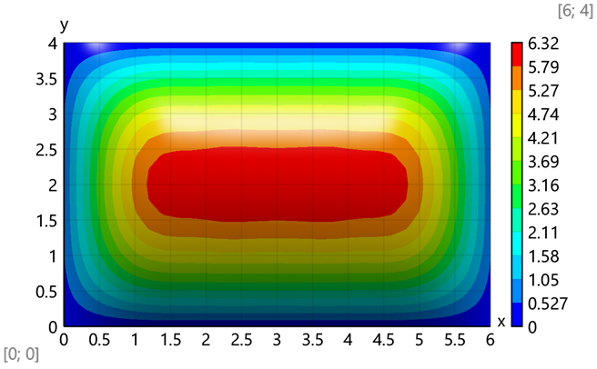
Maximal value - $M_{x}\left(\frac{a}{2};\frac{b}{2}\right)=M_{x}\left(\frac{6}{2};\frac{4}{2}\right)=6.28$ kNm/m

Bending moments - M_{y}
$$\text{transp}\left(My\right)=\left[\begin{matrix}0 & 0.563 & 0.675 & 0.702 & 0.675 & 0.563 & 0 \\ 0.0792 & 5.84 & 9.08 & 10.1 & 9.08 & 5.84 & 0.0792 \\ 0.0892 & 7.04 & 11.33 & 12.74 & 11.33 & 7.04 & 0.0892 \\ 0.0792 & 5.84 & 9.08 & 10.1 & 9.08 & 5.84 & 0.0792 \\ 0 & 0.563 & 0.675 & 0.702 & 0.675 & 0.563 & 0\end{matrix}\right]kNm/m$$
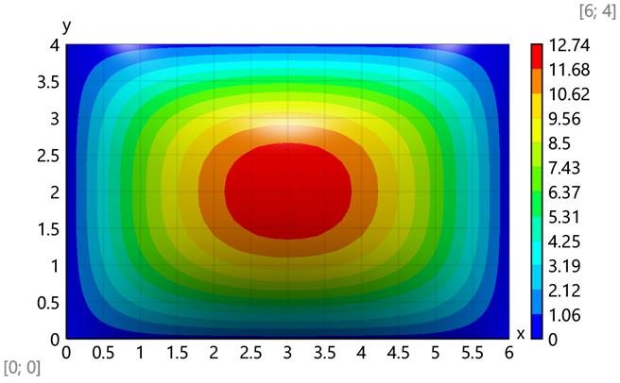
Maximal value - $M_{y}\left(\frac{a}{2};\frac{b}{2}\right)=M_{y}\left(\frac{6}{2};\frac{4}{2}\right)=12.74$ kNm/m
Bending moments - M_{xy}
$$\text{transp}\left(Mxy\right)=\left[\begin{matrix}\text{-}8.38 & \text{-}6.18 & \text{-}3.05 & 0 & 3.05 & 6.18 & 8.38 \\ \text{-}5.31 & \text{-}4.22 & \text{-}2.13 & 0 & 2.13 & 4.22 & 5.31 \\ 0 & 0 & 0 & 0 & 0 & 0 & 0 \\ 5.31 & 4.22 & 2.13 & 0 & \text{-}2.13 & \text{-}4.22 & \text{-}5.31 \\ 8.38 & 6.18 & 3.05 & 0 & \text{-}3.05 & \text{-}6.18 & \text{-}8.38\end{matrix}\right]kNm/m$$
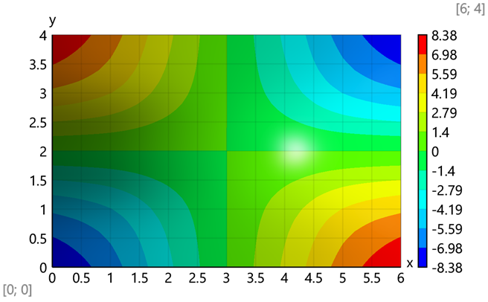
Maximal value - $M_{xy}\left(0;0\right)=\text{-}8.38$ kNm/m

Solution with SAP 2000 structural analysis software
Input data
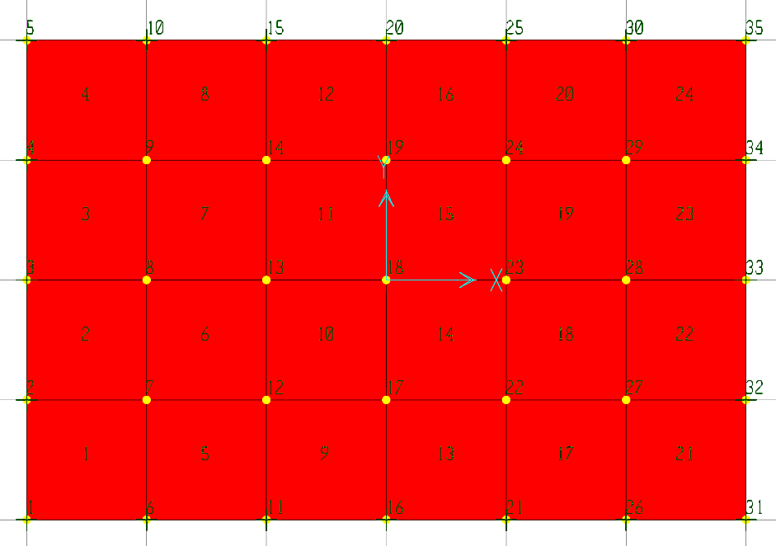

S T A T I C L O A D C A S E S
STATIC CASE SELF WT
CASE TYPE FACTOR
LOAD1 DEAD 0.0000

J O I N T D A T A
JOINT GLOBAL-X GLOBAL-Y GLOBAL-Z RESTRAINTS ANGLE-A ANGLE-B ANGLE-C
1 -3.00000 -2.00000 0.00000 0 0 1 1 1 0 0.000 0.000 0.000
2 -3.00000 -1.00000 0.00000 0 0 1 1 0 0 0.000 0.000 0.000
3 -3.00000 0.00000 0.00000 0 0 1 1 0 0 0.000 0.000 0.000
4 -3.00000 1.00000 0.00000 0 0 1 1 0 0 0.000 0.000 0.000
5 -3.00000 2.00000 0.00000 0 0 1 1 1 0 0.000 0.000 0.000
6 -2.00000 -2.00000 0.00000 0 0 1 0 1 0 0.000 0.000 0.000
7 -2.00000 -1.00000 0.00000 0 0 0 0 0 0 0.000 0.000 0.000
8 -2.00000 0.00000 0.00000 0 0 0 0 0 0 0.000 0.000 0.000
9 -2.00000 1.00000 0.00000 0 0 0 0 0 0 0.000 0.000 0.000
10 -2.00000 2.00000 0.00000 0 0 1 0 1 0 0.000 0.000 0.000
11 -1.00000 -2.00000 0.00000 0 0 1 0 1 0 0.000 0.000 0.000
12 -1.00000 -1.00000 0.00000 0 0 0 0 0 0 0.000 0.000 0.000
13 -1.00000 0.00000 0.00000 0 0 0 0 0 0 0.000 0.000 0.000
14 -1.00000 1.00000 0.00000 0 0 0 0 0 0 0.000 0.000 0.000
15 -1.00000 2.00000 0.00000 0 0 1 0 1 0 0.000 0.000 0.000
16 0.00000 -2.00000 0.00000 0 0 1 0 1 0 0.000 0.000 0.000
17 0.00000 -1.00000 0.00000 0 0 0 0 0 0 0.000 0.000 0.000
18 0.00000 0.00000 0.00000 0 0 0 0 0 0 0.000 0.000 0.000
19 0.00000 1.00000 0.00000 0 0 0 0 0 0 0.000 0.000 0.000
20 0.00000 2.00000 0.00000 0 0 1 0 1 0 0.000 0.000 0.000
21 1.00000 -2.00000 0.00000 0 0 1 0 1 0 0.000 0.000 0.000
22 1.00000 -1.00000 0.00000 0 0 0 0 0 0 0.000 0.000 0.000
23 1.00000 0.00000 0.00000 0 0 0 0 0 0 0.000 0.000 0.000
24 1.00000 1.00000 0.00000 0 0 0 0 0 0 0.000 0.000 0.000
25 1.00000 2.00000 0.00000 0 0 1 0 1 0 0.000 0.000 0.000
26 2.00000 -2.00000 0.00000 0 0 1 0 1 0 0.000 0.000 0.000
27 2.00000 -1.00000 0.00000 0 0 0 0 0 0 0.000 0.000 0.000
28 2.00000 0.00000 0.00000 0 0 0 0 0 0 0.000 0.000 0.000
29 2.00000 1.00000 0.00000 0 0 0 0 0 0 0.000 0.000 0.000
30 2.00000 2.00000 0.00000 0 0 1 0 1 0 0.000 0.000 0.000
31 3.00000 -2.00000 0.00000 0 0 1 1 1 0 0.000 0.000 0.000
32 3.00000 -1.00000 0.00000 0 0 1 1 0 0 0.000 0.000 0.000
33 3.00000 0.00000 0.00000 0 0 1 1 0 0 0.000 0.000 0.000
34 3.00000 1.00000 0.00000 0 0 1 1 0 0 0.000 0.000 0.000
35 3.00000 2.00000 0.00000 0 0 1 1 1 0 0.000 0.000 0.000

S H E L L E L E M E N T D A T A
SHELL JNT-1 JNT-2 JNT-3 JNT-4 SECTION ANGLE AREA
1 1 6 2 7 SSEC1 0.000 1.000
2 2 7 3 8 SSEC1 0.000 1.000
3 3 8 4 9 SSEC1 0.000 1.000
4 4 9 5 10 SSEC1 0.000 1.000
5 6 11 7 12 SSEC1 0.000 1.000
6 7 12 8 13 SSEC1 0.000 1.000
7 8 13 9 14 SSEC1 0.000 1.000
8 9 14 10 15 SSEC1 0.000 1.000
9 11 16 12 17 SSEC1 0.000 1.000
10 12 17 13 18 SSEC1 0.000 1.000
11 13 18 14 19 SSEC1 0.000 1.000
12 14 19 15 20 SSEC1 0.000 1.000
13 16 21 17 22 SSEC1 0.000 1.000
14 17 22 18 23 SSEC1 0.000 1.000
15 18 23 19 24 SSEC1 0.000 1.000
16 19 24 20 25 SSEC1 0.000 1.000
17 21 26 22 27 SSEC1 0.000 1.000
18 22 27 23 28 SSEC1 0.000 1.000
19 23 28 24 29 SSEC1 0.000 1.000
20 24 29 25 30 SSEC1 0.000 1.000
21 26 31 27 32 SSEC1 0.000 1.000
22 27 32 28 33 SSEC1 0.000 1.000
23 28 33 29 34 SSEC1 0.000 1.000
24 29 34 30 35 SSEC1 0.000 1.000

S H E L L U N I F O R M L O A D S Load Case LOAD1
SHELL DIRECTION VALUE
1 GLOBAL-Z -10.0000
2 GLOBAL-Z -10.0000
3 GLOBAL-Z -10.0000
4 GLOBAL-Z -10.0000
5 GLOBAL-Z -10.0000
6 GLOBAL-Z -10.0000
7 GLOBAL-Z -10.0000
8 GLOBAL-Z -10.0000
9 GLOBAL-Z -10.0000
10 GLOBAL-Z -10.0000
11 GLOBAL-Z -10.0000
12 GLOBAL-Z -10.0000
13 GLOBAL-Z -10.0000
14 GLOBAL-Z -10.0000
15 GLOBAL-Z -10.0000
16 GLOBAL-Z -10.0000
17 GLOBAL-Z -10.0000
18 GLOBAL-Z -10.0000
19 GLOBAL-Z -10.0000
20 GLOBAL-Z -10.0000
21 GLOBAL-Z -10.0000
22 GLOBAL-Z -10.0000
23 GLOBAL-Z -10.0000
24 GLOBAL-Z -10.0000
Results
Displacements, mm
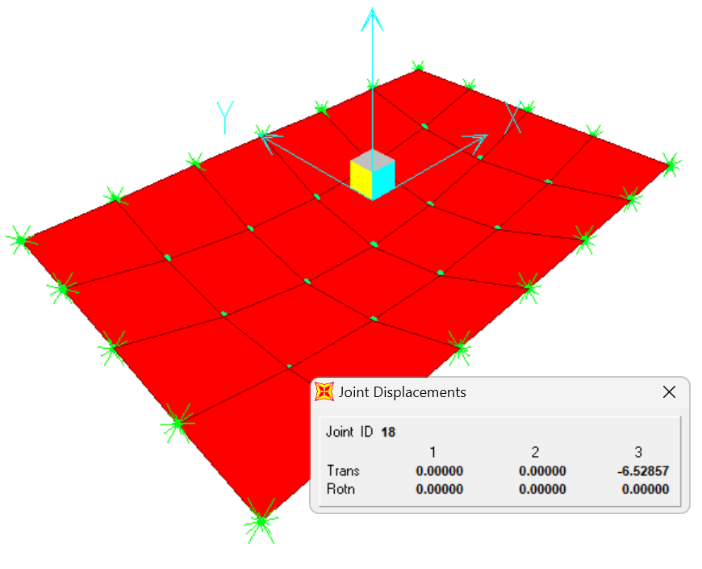
Bending moments - M11, kNm/m
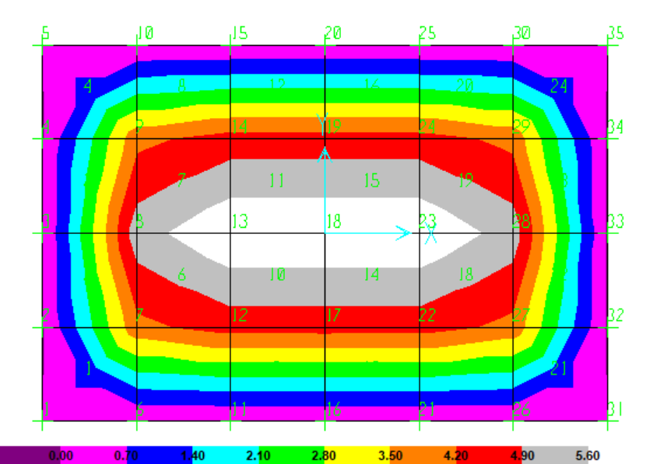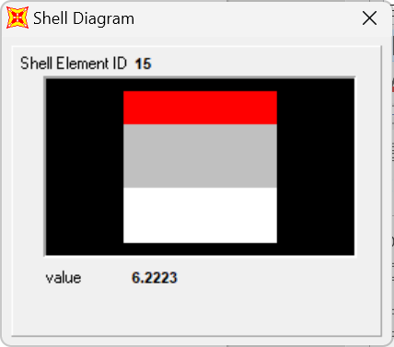
Bending moments - M22, kNm/m
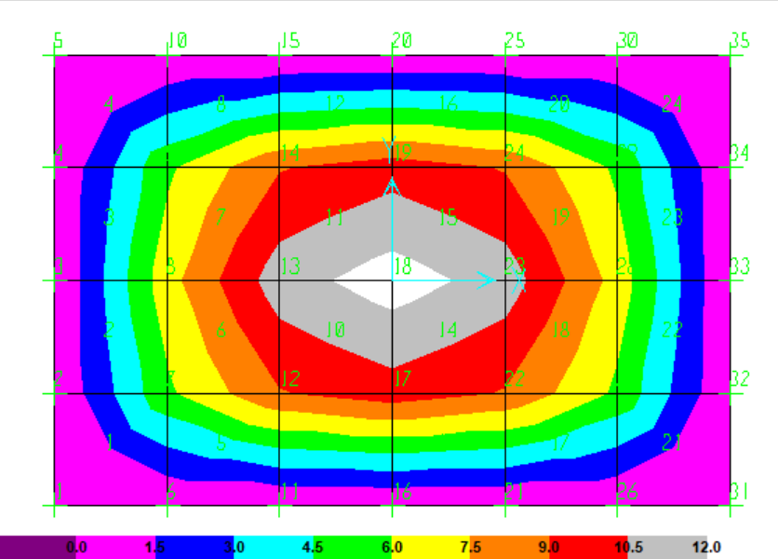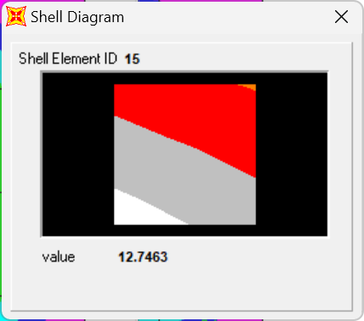
Bending moments - M12, kNm/m
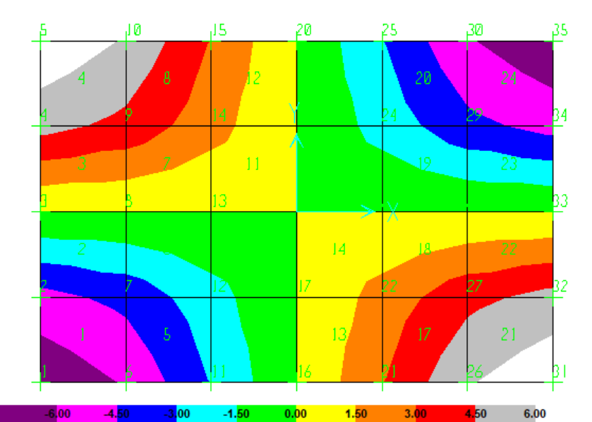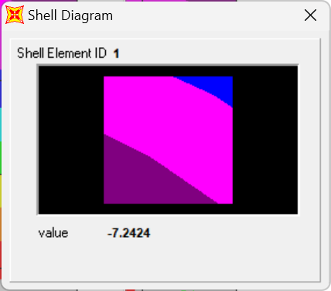
J O I N T D I S P L A C E M E N T S
JOINT LOAD U3 R1 R2
1 LOAD1 0.0000 0.0000 0.0000
2 LOAD1 0.0000 0.0000 2.685E-03
3 LOAD1 0.0000 0.0000 3.743E-03
4 LOAD1 0.0000 0.0000 2.685E-03
5 LOAD1 0.0000 0.0000 0.0000
6 LOAD1 0.0000 -2.797E-03 0.0000
7 LOAD1 -2.509E-03 -1.927E-03 2.151E-03
8 LOAD1 -3.503E-03 0.0000 3.016E-03
9 LOAD1 -2.509E-03 1.927E-03 2.151E-03
10 LOAD1 0.0000 2.797E-03 0.0000
11 LOAD1 0.0000 -4.588E-03 0.0000
12 LOAD1 -4.122E-03 -3.184E-03 1.070E-03
13 LOAD1 -5.777E-03 0.0000 1.514E-03
14 LOAD1 -4.122E-03 3.184E-03 1.070E-03
15 LOAD1 0.0000 4.588E-03 0.0000
16 LOAD1 0.0000 -5.176E-03 0.0000
17 LOAD1 -4.653E-03 -3.600E-03 0.0000
18 LOAD1 -6.529E-03 0.0000 0.0000
19 LOAD1 -4.653E-03 3.600E-03 0.0000
20 LOAD1 0.0000 5.176E-03 0.0000
21 LOAD1 0.0000 -4.588E-03 0.0000
22 LOAD1 -4.122E-03 -3.184E-03 -1.070E-03
23 LOAD1 -5.777E-03 0.0000 -1.514E-03
24 LOAD1 -4.122E-03 3.184E-03 -1.070E-03
25 LOAD1 0.0000 4.588E-03 0.0000
26 LOAD1 0.0000 -2.797E-03 0.0000
27 LOAD1 -2.509E-03 -1.927E-03 -2.151E-03
28 LOAD1 -3.503E-03 0.0000 -3.016E-03
29 LOAD1 -2.509E-03 1.927E-03 -2.151E-03
30 LOAD1 0.0000 2.797E-03 0.0000
31 LOAD1 0.0000 0.0000 0.0000
32 LOAD1 0.0000 0.0000 -2.685E-03
33 LOAD1 0.0000 0.0000 -3.743E-03
34 LOAD1 0.0000 0.0000 -2.685E-03
35 LOAD1 0.0000 0.0000 0.0000

S H E L L E L E M E N T R E S U L T A N T S
SHELL LOAD JOINT M11 M22 M12 V13 V23
1 LOAD1
1 0.00 0.00 -7.25 -1.10 -6.699E-01
6 -6.603E-03 -4.402E-02 -6.58 -1.10 -6.44
2 -4.402E-02 -6.603E-03 -6.15 -5.16 -6.699E-01
7 4.01 5.72 -5.47 -5.16 -6.44
2 LOAD1
2 -4.402E-02 -6.603E-03 -3.87 -6.49 -2.463E-01
7 4.01 5.68 -3.62 -6.49 -1.52
3 -3.938E-02 -5.907E-03 -1.42 -7.81 -2.463E-01
8 5.32 6.96 -1.18 -7.81 -1.52
3 LOAD1
3 -3.938E-02 -5.907E-03 1.42 -7.81 2.463E-01
8 5.32 6.96 1.18 -7.81 1.52
4 -4.402E-02 -6.603E-03 3.87 -6.49 2.463E-01
9 4.01 5.68 3.62 -6.49 1.52
4 LOAD1
4 -4.402E-02 -6.603E-03 6.15 -5.16 6.699E-01
9 4.01 5.72 5.47 -5.16 6.44
5 0.00 0.00 7.25 -1.10 6.699E-01
10 -6.603E-03 -4.402E-02 6.58 -1.10 6.44
5 LOAD1
6 -6.603E-03 -4.402E-02 -5.11 -6.776E-01 -7.13
11 -5.610E-03 -3.740E-02 -3.74 -6.776E-01 -10.31
7 3.98 5.72 -4.44 -1.22 -7.13
12 4.52 8.90 -3.07 -1.22 -10.31
6 LOAD1
7 3.97 5.68 -2.74 -2.14 -1.81
12 4.51 8.85 -2.21 -2.14 -3.02
8 5.27 6.95 -1.15 -2.56 -1.81
13 6.23 11.33 -6.135E-01 -2.56 -3.02
7 LOAD1
8 5.27 6.95 1.15 -2.56 1.81
13 6.23 11.33 6.135E-01 -2.56 3.02
9 3.97 5.68 2.74 -2.14 1.81
14 4.51 8.85 2.21 -2.14 3.02
8 LOAD1
9 3.98 5.72 4.44 -1.22 7.13
14 4.52 8.90 3.07 -1.22 10.31
10 -6.603E-03 -4.402E-02 5.11 -6.776E-01 7.13
15 -5.610E-03 -3.740E-02 3.74 -6.776E-01 10.31
9 LOAD1
11 -5.610E-03 -3.740E-02 -2.13 -2.181E-01 -10.30
16 -5.365E-03 -3.577E-02 -7.767E-01 -2.181E-01 -11.30
12 4.53 8.91 -1.92 -2.197E-01 -10.30
17 4.53 9.91 -5.589E-01 -2.197E-01 -11.30
10 LOAD1
12 4.52 8.85 -1.10 -5.303E-01 -3.04
17 4.53 9.86 -5.411E-01 -5.303E-01 -3.47
13 6.22 11.33 -5.763E-01 -5.303E-01 -3.04
18 6.22 12.76 -1.303E-02 -5.303E-01 -3.47
11 LOAD1
13 6.22 11.33 5.763E-01 -5.303E-01 3.04
18 6.22 12.76 1.303E-02 -5.303E-01 3.47
14 4.52 8.85 1.10 -5.303E-01 3.04
19 4.53 9.86 5.411E-01 -5.303E-01 3.47
12 LOAD1
14 4.53 8.91 1.92 -2.197E-01 10.30
19 4.53 9.91 5.589E-01 -2.197E-01 11.30
15 -5.610E-03 -3.740E-02 2.13 -2.181E-01 10.30
20 -5.365E-03 -3.577E-02 7.767E-01 -2.181E-01 11.30
13 LOAD1
16 -5.365E-03 -3.577E-02 7.767E-01 2.181E-01 -11.30
21 -5.610E-03 -3.740E-02 2.13 2.181E-01 -10.30
17 4.53 9.91 5.589E-01 2.197E-01 -11.30
22 4.53 8.91 1.92 2.197E-01 -10.30
14 LOAD1
17 4.53 9.86 5.411E-01 5.303E-01 -3.47
22 4.52 8.85 1.10 5.303E-01 -3.04
18 6.22 12.76 1.303E-02 5.303E-01 -3.47
23 6.22 11.33 5.763E-01 5.303E-01 -3.04
15 LOAD1
18 6.22 12.76 -1.303E-02 5.303E-01 3.47
23 6.22 11.33 -5.763E-01 5.303E-01 3.04
19 4.53 9.86 -5.411E-01 5.303E-01 3.47
24 4.52 8.85 -1.10 5.303E-01 3.04
16 LOAD1
19 4.53 9.91 -5.589E-01 2.197E-01 11.30
24 4.53 8.91 -1.92 2.197E-01 10.30
20 -5.365E-03 -3.577E-02 -7.767E-01 2.181E-01 11.30
25 -5.610E-03 -3.740E-02 -2.13 2.181E-01 10.30
17 LOAD1
21 -5.610E-03 -3.740E-02 3.74 6.776E-01 -10.31
26 -6.603E-03 -4.402E-02 5.11 6.776E-01 -7.13
22 4.52 8.90 3.07 1.22 -10.31
27 3.98 5.72 4.44 1.22 -7.13
18 LOAD1
22 4.51 8.85 2.21 2.14 -3.02
27 3.97 5.68 2.74 2.14 -1.81
23 6.23 11.33 6.135E-01 2.56 -3.02
28 5.27 6.95 1.15 2.56 -1.81
19 LOAD1
23 6.23 11.33 -6.135E-01 2.56 3.02
28 5.27 6.95 -1.15 2.56 1.81
24 4.51 8.85 -2.21 2.14 3.02
29 3.97 5.68 -2.74 2.14 1.81
20 LOAD1
24 4.52 8.90 -3.07 1.22 10.31
29 3.98 5.72 -4.44 1.22 7.13
25 -5.610E-03 -3.740E-02 -3.74 6.776E-01 10.31
30 -6.603E-03 -4.402E-02 -5.11 6.776E-01 7.13
21 LOAD1
26 -6.603E-03 -4.402E-02 6.58 1.10 -6.44
31 0.00 0.00 7.25 1.10 -6.699E-01
27 4.01 5.72 5.47 5.16 -6.44
32 -4.402E-02 -6.603E-03 6.15 5.16 -6.699E-01
22 LOAD1
27 4.01 5.68 3.62 6.49 -1.52
32 -4.402E-02 -6.603E-03 3.87 6.49 -2.463E-01
28 5.32 6.96 1.18 7.81 -1.52
33 -3.938E-02 -5.907E-03 1.42 7.81 -2.463E-01
23 LOAD1
28 5.32 6.96 -1.18 7.81 1.52
33 -3.938E-02 -5.907E-03 -1.42 7.81 2.463E-01
29 4.01 5.68 -3.62 6.49 1.52
34 -4.402E-02 -6.603E-03 -3.87 6.49 2.463E-01
24 LOAD1
29 4.01 5.72 -5.47 5.16 6.44
34 -4.402E-02 -6.603E-03 -6.15 5.16 6.699E-01
30 -6.603E-03 -4.402E-02 -6.58 1.10 6.44
35 0.00 0.00 -7.25 1.10 6.699E-01
Analytical solution
$$\text{Cylindrical stiffness - }D=\frac{E·t^{3}}{12·\left(1-ν^{2}\right)}=\frac{35000\text{ MPa}·{\left(0.1\text{ m}\right)}^{3}}{12·\left(1-{0.15}^{2}\right)}=2983.8\text{ kNm}$$
$$α=\frac{a}{b}=\frac{6\text{ m}}{4\text{ m}}=1.5, α_{2}=α^{2}={1.5}^{2}=2.25$$
$$q_{0}=\frac{16·q}{π^{2}}=\frac{16·10\text{ kN}/{\text{ m}}^{2}}{{3.14}^{2}}=16.21\text{ kN}/{\text{ m}}^{2}$$
Auxiliary functions
$$k\left(n\right)=2·n+1, k_{2}\left(n\right)=4·n·\left(n+1\right)+1$$
$$A\left(m;n\right)=k_{2}\left(m\right)+α_{2}·k_{2}\left(n\right) => A_{1}\left(m;n\right)=\frac{1}{{A\left(m;n\right)}^{2}}$$
$$B\left(m;n\right)=k_{2}\left(m\right)+ν·α_{2}·k_{2}\left(n\right) => B_{1}\left(m;n\right)=\frac{B\left(m;n\right)}{{A\left(m;n\right)}^{2}}$$
$$C\left(m;n\right)=ν·k_{2}\left(m\right)+α_{2}·k_{2}\left(n\right) => C_{1}\left(m;n\right)=\frac{C\left(m;n\right)}{{A\left(m;n\right)}^{2}}$$
$$S_{a}\left(m;x\right)=\frac{\text{sin}\left(\frac{k\left(m\right)·π}{a}·x\right)}{k\left(m\right)}, S_{b}\left(n;y\right)=\frac{\text{sin}\left(\frac{k\left(n\right)·π}{b}·y\right)}{k\left(n\right)}$$

Deflections
$$w\left(x;y\right)=\frac{q_{0}·{\left(\frac{a}{π}\right)}^{4}}{D}·\sum_{m=0}^{N}{S_{a}\left(m;x\right)·\sum_{n=0}^{N}{A_{1}\left(m;n\right)·S_{b}\left(n;y\right)}}$$
Bending moments
$$M_{x}\left(x;y\right)=q_{0}·{\left(\frac{a}{π}\right)}^{2}·\sum_{m=0}^{N}{S_{a}\left(m;x\right)·\sum_{n=0}^{N}{B_{1}\left(m;n\right)·S_{b}\left(n;y\right)}}$$
$$M_{y}\left(x;y\right)=q_{0}·{\left(\frac{a}{π}\right)}^{2}·\sum_{m=0}^{N}{S_{a}\left(m;x\right)·\sum_{n=0}^{N}{C_{1}\left(m;n\right)·S_{b}\left(n;y\right)}}$$
$$k_{1}\left(n\right)=2·n$$
$$M_{xy}\left(x;y\right)=\text{-}q_{0}·{\left(\frac{a}{π}\right)}^{2}·\left(1-ν\right)·α·\sum_{m=0}^{N}{\text{cos}\left(\frac{k\left(m\right)·π·x}{a}\right)·\sum_{n=0}^{N}{A_{1}\left(m;n\right)·\text{cos}\left(\frac{k\left(n\right)·π·y}{b}\right)}}$$
Principal bending moments
$$M_{max}\left(x;y\right)=\frac{M_{x}\left(x;y\right)+M_{y}\left(x;y\right)}{2}+\sqrt{\frac{{\left(M_{x}\left(x;y\right)-M_{y}\left(x;y\right)\right)}^{2}}{4}+{M_{xy}\left(x;y\right)}^{2}}$$
$$M_{min}\left(x;y\right)=\frac{M_{x}\left(x;y\right)+M_{y}\left(x;y\right)}{2}-\sqrt{\frac{{\left(M_{x}\left(x;y\right)-M_{y}\left(x;y\right)\right)}^{2}}{4}+{M_{xy}\left(x;y\right)}^{2}}$$
Results
Deflections, mm
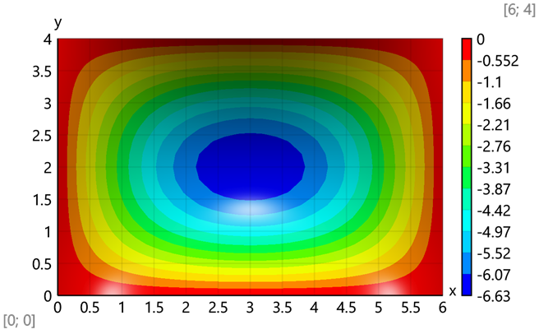
$$\text{Maximum value - }w\left(\frac{a}{2};\frac{b}{2}\right)=w\left(\frac{6\text{ m}}{2};\frac{4\text{ m}}{2}\right)=6.63\text{ m}\text{m}$$

Bending moments - M_{x}, kNm/m
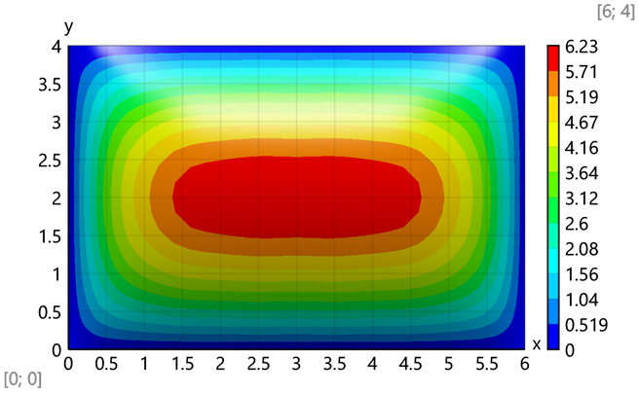
$$\text{Maximum value -}{\text{M}}_{\text{x}}\left(\frac{a}{2};\frac{b}{2}\right)=M_{x}\left(\frac{6\text{ m}}{2};\frac{4\text{ m}}{2}\right)=6.22\text{ kNm}/\text{ m}$$
Bending moments - M_{y}, kNm/m
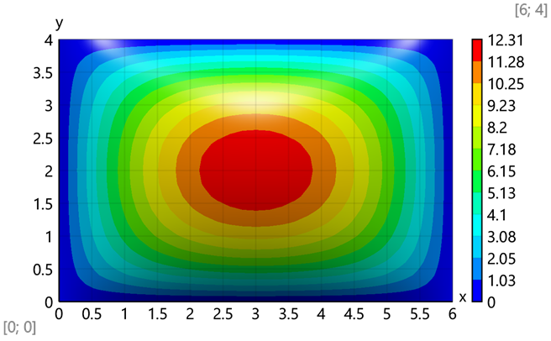
$$\text{Maximum value - }M_{y}\left(\frac{a}{2};\frac{b}{2}\right)=M_{y}\left(\frac{6\text{ m}}{2};\frac{4\text{ m}}{2}\right)=12.31\text{ kNm}/\text{ m}$$
Bending moments - M_{xy}, kNm/m
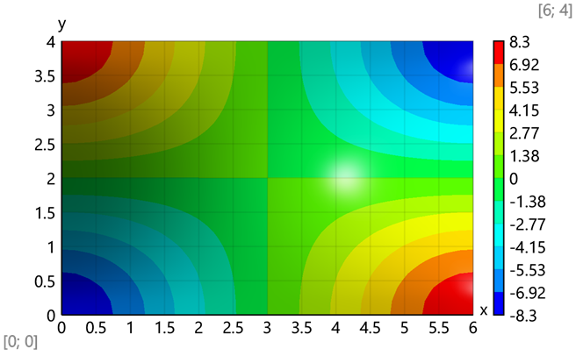
Maximum value - $M_{xy}\left(0\text{ m};0 \text{m}\right)=\text{-}8.3 \text{kNm}/\text{ m}$
Comparison of the results
 | Analytical | FEA Calcpad | FEA SAP 2000
w, mm | 6,627 | 6,629 | 6,529
Mx, kNm/m | 6,231 | 6,275 | 6,22
My, kNm/m | 12,315 | 12,744 | 12,76
Mxy, kNm/m | 8,329 | 8,378 | 7,25
Difference, %
 | Analytical | FEA Calcpad | FEA SAP 2000
w, mm | 0,00% | 0,03% | -1,48%
Mx, kNm/m | 0,00% | 0,71% | -0,18%
My, kNm/m | 0,00% | 3,48% | 3,61%
Mxy, kNm/m | 0,00% | 0,59% | -12,95%

